**Trapping Rain Water**

Question

You are given an array of k linked-lists lists, each linked-list is sorted in ascending order.

*Merge all the linked-lists into one sorted linked-list and return it.*

**Example 1:**

**Input:** lists = [[1,4,5],[1,3,4],[2,6]]

**Output:** [1,1,2,3,4,4,5,6]

**Explanation:** The linked-lists are:

[

1->4->5,

1->3->4,

2->6

]

merging them into one sorted list:

1->1->2->3->4->4->5->6

**Example 2:**

**Input:** lists = []

**Output:** []

**Example 3:**

**Input:** lists = [[]]

**Output:** []

**Constraints:**

* k == lists.length
* 0 <= k <= 10^4
* 0 <= lists[i].length <= 500
* -10^4 <= lists[i][j] <= 10^4
* lists[i] is sorted in **ascending order**.
* The sum of lists[i].length won't exceed 10^4.

# **Solution**

#### **Approach 1: Brute Force**

**Intuition & Algorithm**

* Traverse all the linked lists and collect the values of the nodes into an array.
* Sort and iterate over this array to get the proper value of nodes.
* Create a new sorted linked list and extend it with the new nodes.

As for sorting, you can refer [here](https://www.cs.cmu.edu/~adamchik/15-121/lectures/Sorting%20Algorithms/sorting.html) for more about sorting algorithms.

Coding Solution

Python

|  |
| --- |
| class Solution(object):  def mergeKLists(self, lists):  """  :type lists: List[ListNode]  :rtype: ListNode  """  self.nodes = []  head = point = ListNode(0)  for l in lists:  while l:  self.nodes.append(l.val)  l = l.next  for x in sorted(self.nodes):  point.next = ListNode(x)  point = point.next  return head.next |

**Complexity Analysis**

* Time complexity : O(N\log N)*O*(*N*log*N*) where N*N* is the total number of nodes.
  + Collecting all the values costs O(N)*O*(*N*) time.
  + A stable sorting algorithm costs O(N\log N)*O*(*N*log*N*) time.
  + Iterating for creating the linked list costs O(N)*O*(*N*) time.
* Space complexity : O(N)*O*(*N*).
  + Sorting cost O(N)*O*(*N*) space (depends on the algorithm you choose).
  + Creating a new linked list costs O(N)*O*(*N*) space.

#### **Approach 2: Compare one by one**

**Algorithm**

* Compare every \text{k}k nodes (head of every linked list) and get the node with the smallest value.
* Extend the final sorted linked list with the selected nodes.

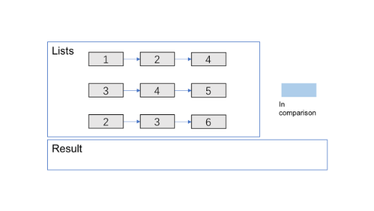

1 / 11

**Complexity Analysis**

* Time complexity : O(kN)*O*(*kN*) where \text{k}k is the number of linked lists.
  + Almost every selection of node in final linked costs O(k)*O*(*k*) (\text{k-1}k-1 times comparison).
  + There are N*N* nodes in the final linked list.
* Space complexity :
  + O(n)*O*(*n*) Creating a new linked list costs O(n)*O*(*n*) space.
  + O(1)*O*(1) It's not hard to apply in-place method - connect selected nodes instead of creating new nodes to fill the new linked list.

#### **Approach 3: Optimize Approach 2 by Priority Queue**

**Algorithm**

Almost the same as the one above but optimize the **comparison process** by **priority queue**. You can refer [here](https://en.wikipedia.org/wiki/Priority_queue) for more information about it.

Coding Solution

Python

|  |
| --- |
| from Queue import PriorityQueue  class Solution(object):  def mergeKLists(self, lists):  """  :type lists: List[ListNode]  :rtype: ListNode  """  head = point = ListNode(0)  q = PriorityQueue()  for l in lists:  if l:  q.put((l.val, l))  while not q.empty():  val, node = q.get()  point.next = ListNode(val)  point = point.next  node = node.next  if node:  q.put((node.val, node))  return head.next |

**Complexity Analysis**

* Time complexity : O(N\log k)*O*(*N*log*k*) where \text{k}k is the number of linked lists.
  + The comparison cost will be reduced to O(\log k)*O*(log*k*) for every pop and insertion to priority queue. But finding the node with the smallest value just costs O(1)*O*(1) time.
  + There are N*N* nodes in the final linked list.
* Space complexity :
  + O(n)*O*(*n*) Creating a new linked list costs O(n)*O*(*n*) space.
  + O(k)*O*(*k*) The code above present applies in-place method which cost O(1)*O*(1) space. And the priority queue (often implemented with heaps) costs O(k)*O*(*k*) space (it's far less than N*N* in most situations).

#### **Approach 4: Merge lists one by one**

Algorithm

Convert merge \text{k}k lists problem to merge 2 lists (\text{k-1}k-1) times. Here is the [merge 2 lists](https://leetcode.com/problems/merge-two-sorted-lists/description/) problem page.

Complexity Analysis

* Time complexity : O(kN)*O*(*kN*) where \text{k}k is the number of linked lists.
  + We can merge two sorted linked list in O(n)*O*(*n*) time where n*n* is the total number of nodes in two lists.
  + Sum up the merge process and we can get: O(\sum_{i=1}^{k-1} (i*(\frac{N}{k}) + \frac{N}{k})) = O(kN)*O*(∑*i*=1*k*−1​(*i*∗(*kN*​)+*kN*​))=*O*(*kN*).
* Space complexity : O(1)*O*(1)
  + We can merge two sorted linked list in O(1)*O*(1) space.

#### **Approach 5: Merge with Divide And Conquer**

**Intuition & Algorithm**

This approach walks alongside the one above but is improved a lot. We don't need to traverse most nodes many times repeatedly

* Pair up \text{k}k lists and merge each pair.
* After the first pairing, \text{k}k lists are merged into k/2*k*/2 lists with average 2N/k2*N*/*k* length, then k/4*k*/4, k/8*k*/8 and so on.
* Repeat this procedure until we get the final sorted linked list.

Thus, we'll traverse almost N*N* nodes per pairing and merging, and repeat this procedure about \log_{2}{k}log2​*k* times.

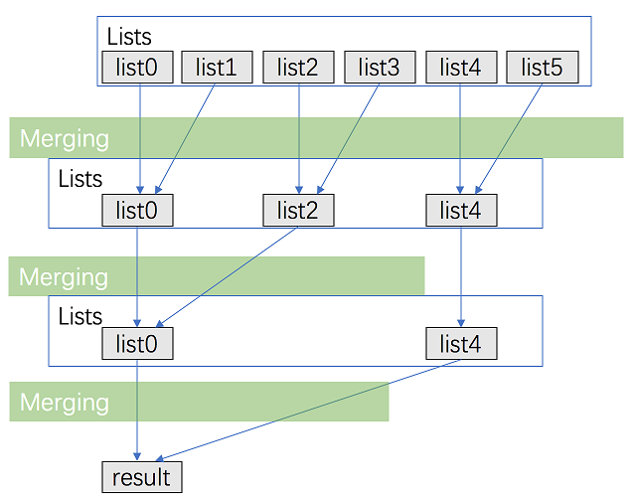

Coding Solution

Python

|  |
| --- |
| class Solution(object):  def mergeKLists(self, lists):  """  :type lists: List[ListNode]  :rtype: ListNode  """  amount = len(lists)  interval = 1  while interval < amount:  for i in range(0, amount - interval, interval * 2):  lists[i] = self.merge2Lists(lists[i], lists[i + interval])  interval *= 2  return lists[0] if amount > 0 else None  def merge2Lists(self, l1, l2):  head = point = ListNode(0)  while l1 and l2:  if l1.val <= l2.val:  point.next = l1  l1 = l1.next  else:  point.next = l2  l2 = l1  l1 = point.next.next  point = point.next  if not l1:  point.next=l2  else:  point.next=l1  return head.next |

**Complexity Analysis**

* Time complexity : O(N\log k)*O*(*N*log*k*) where \text{k}k is the number of linked lists.
  + We can merge two sorted linked list in O(n)*O*(*n*) time where n*n* is the total number of nodes in two lists.
  + Sum up the merge process and we can get: O\big(\sum_{i=1}^{log_{2}{k}}N \big)= O(N\log k)*O*(∑*i*=1*log*2​*k*​*N*)=*O*(*N*log*k*)
* Space complexity : O(1)*O*(1)
  + We can merge two sorted linked lists in O(1)*O*(1) space.

https://www.youtube.com/watch?v=q5a5OiGbT6Q